FTC Monthly April Meeting
Matt Fitzgerald: Author, Coach, Nutritionist!
from mattfitzgerald.org: Matt Fitzgerald is an acclaimed author, highly sought-after coach of runners and triathletes, and sports nutritionist of worldwide reputation. His mission is to inspire, educate, and help athletes and fitness enthusiasts achieve their goals.
Come hear Matt speak to the FTC on Monday, April 6th, 7:30PM OSMI
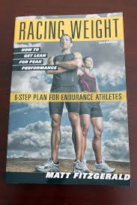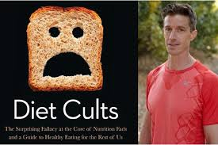

FTC Monthly April Meeting
Matt Fitzgerald: Author, Coach, Nutritionist!
from mattfitzgerald.org: Matt Fitzgerald is an acclaimed author, highly sought-after coach of runners and triathletes, and sports nutritionist of worldwide reputation. His mission is to inspire, educate, and help athletes and fitness enthusiasts achieve their goals.
Come hear Matt speak to the FTC on Monday, April 6th, 7:30PM OSMI

